Application Guideline

BACKGROUND

Bangladesh’s unique geography, and population density make it extremely vulnerable to climate change and its effects. 90 million Bangladeshis live in ‘high climate exposure’ areas with 53 million (33% of total population) facing very high climate exposure.
With almost 41% of Bangladesh’s population dependent on agriculture for their livelihood and approximately 77.35% of land dedicated to growing crops, addressing the threats to agriculture and food security are critical for this country’s ability to survive the impacts of climate change.
The Climate Innovation Fund (CIF) is committed to supporting initiatives that strengthen Bangladesh's capacity to adapt to climate change and build resilience. This funding call will focus on innovative solutions by local enterprises that address climate change within the agriculture sector.

THEME ELIGIBILITY: AGRICULTURE

Eligible enterprises may include innovations that advance one or more of the following:
- Climate-Smart and Resilient Agriculture:
  - Climate-resilient and climate-smart agricultural practices to adapt to and mitigate the impacts of climate change.
  - Introduction of new crop varieties, livestock breeds, and fisheries that enhance climate resilience.
- Agricultural Technology and Innovation:
  - Adoption of innovative cultivation methods and agro-equipment to boost agricultural productivity.
  - Utilization of advanced agricultural technologies to improve efficiency and sustainability.
- Nature-Based Solutions:
  - Integration of nature-based approaches to restore ecosystems and support sustainable farming practices.
- Agri-Financing:
  - Access to financial solutions tailored to support climate-smart and resilient agriculture, promoting long-term sustainability.
Selected enterprises must demonstrate a direct and positive impact on farmers and farming communities.

GEOGRAPHY

The solution / initiative must be implemented in one or more districts listed as a Hotspot in the Bangladesh Delta Plan 2100. Applicants must ensure and be able to clearly demonstrate that their business model and impact are tailored to and aligned with the specific regional needs to address climate change and enhance climate resilience.

SUPPORT STREAMS

For this call, applicants may apply to either one of two separate support streams:
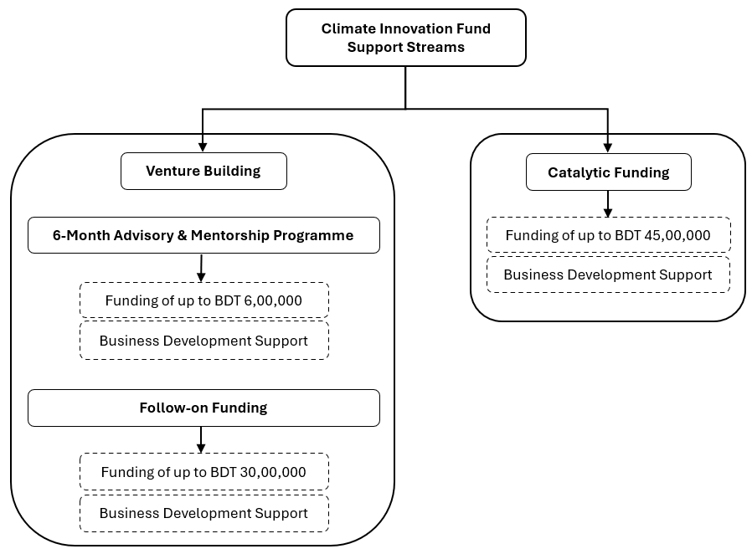

- Venture Building:

Suitable for early-stage ventures or initiatives in the pre-market rollout phase, where the idea or prototype has been validated through initial research, proof of concept, or small-scale testing. The venture should demonstrate potential for scalability and market demand but may still require support in areas such as business model refinement, product development, and go-to-market strategies.

For this stream, selected ventures will be able to access
- ​6 months of advisory, mentorship, & training,
- business development services, and
- ​funding

- Catalytic Funding

Ventures with a product or service in the early stages of market rollout. These ventures should have early customer traction, clear market validation, or initial revenues, and are looking for resources to scale, improve operations, or expand their market reach.

Applicants are requested to check the eligibility for each of the two support streams (given below) before submitting their proposal. Proposals that are submitted but are not eligible for their proposed support stream may be rejected.

VENTURE BUILDING

4.1.1. Eligibility

The applicant must meet the following criteria to be eligible for the Climate Innovation Fund’s Venture Building support stream:
- Location:
  - Primary business operations & impact location must be within Bangladesh.
- Thematic Focus:
  - Primary business must involve operating within or supporting agriculture value chains. Please see theme eligibility in Section 2.
  - Must demonstrate a direct and positive impact on farmers and farming communities.
- Legal Status:
- Must be operating as a Sole Proprietorship, Partnership, Limited Company, or NGO. Consortiums are also eligible to apply.
- HR Composition:
  - Founder and/or the Chief Executive Officer must be involved in the enterprise on a full-time basis.
- Advisory & Mentorship:
  - The applicant must be willing to take the six-month advisory and mentorship support and be willing to dedicate the required time for the same.
- Business Development Services:
  - Must be willing to take business development support assigned by the Fund.
- Reach:
  - Business ideas should target to reach at least 50 farmers across the target region(s). Those eligible for follow-on funding must target to reach at least 500 farmers in the target region(s).
- Exclusion:
  - If the product or service is already in the market rollout phase, these initiatives are not eligible to apply for this stream.

4.1.2. Funding

- Venture-Building Grant:
Selected applicant(s) will receive grants of up to a total of BDT 6,00,000 each. The grant will be disbursed in instalments over a 6-month period during the advisory and mentorship programme and will be tied to the achievement of set KPIs.
- Follow-on Grant:
The most promising enterprise(s) from those that graduate from the Venture Building programme will be eligible to receive follow-on funding of up to BDT 30,00,000 each. This funding will be outcome-linked and disbursed in tranches.
With this support, enterprises are expected to achieve:
- Improved traction
- Sustainable revenue growth
- Robust operational processes

Advisory and Mentorship Programme

Enterprises selected to receive Venture-Building Grants are required to participate in a 6-month advisory and mentorship programme, which will include:
- Workshops and training: Grantees will have the opportunity to participate in curated workshops and training sessions to help them develop and refine their solutions as well as structure their operations.
- Advisory and mentorship: Grantees will receive hands-on guidance and mentorship over six months from a team of technical and business experts to help refine their business models, develop valuable networks, and access resources and additional funding.
- Business Development Support: ​Business development support (BDS) will be provided to all companies on a need-basis and throughout the advisory & mentorship programme as well as during the follow-on funding period. BDS will include Finance, IT, Administration and Procurement, HR, and Internal Audit / Compliance support to ensure that enterprises have established policies and structures for smooth operational functioning.

Application and selection process

Application and selection will involve the following three stages for the Venture-Building Grant:
- Application & Pitch Deck Submission:
Applicants are initially required to submit an application and pitch deck from which the most promising ideas/innovations will be selected.
- Due Diligence:
Shortlisted candidates will be requested to undergo due diligence which includes, but is not limited to, interviews with founders, visits to operational sites / offices, sector expert assessment interviews / visits to evaluate product / service / solution, and data room assessment.
- Selection & Contracting:
Upon successfully undergoing due diligence, the top applicants will be selected to enter the Venture Building Programme. Selected applicants will be required to sign an agreement after which the grant funding will be disbursed.

Application and selection will involve the following two stages for the Follow-on Grant:
- Proposal Submission & Due Diligence:
At the end of the 6-month Venture Building Programme, the top performing participants will be invited to apply for follow-on funding of up to BDT 30,00,000. At this stage they will be required to submit a proposal, along with financial and traction projections, a pitch deck, as well as undergo further due-diligence.

- Selection Committee Pitch, Selection, & Contracting:
After an initial screening of the applications and based on due diligence findings, shortlisted applicants will then be invited to pitch to a Selection Committee comprising of investment and sector experts. Once the committee has selected the winners of the follow-on grant, an agreement will be signed with each selected enterprise. The grant funding will be disbursed in tranches and tied to KPIs.

CATALYTIC FUNDING

Eligibility

The applicant must meet the following criteria to be eligible for the CIF’s Catalytic Funding support stream:
- Location:
  - Primary business operations & impact location must be within Bangladesh.
- Thematic Focus:
  - Primary business must involve operating within or supporting agriculture value chains. Please see theme eligibility in Section 2.
  - Must demonstrate a direct and positive impact on farmers and farming communities.
- Legal Status:
  - Must be operating as a Sole Proprietorship, Partnership, Limited Company, or NGO. Consortiums are also eligible to apply.
- HR composition:
- Founder and/or the Chief Executive Officer must be involved in the enterprise on a full-time basis.
- Business development services:
  - Must be willing to take business development support assigned by the Fund.
- Reach:
  - Business ideas should target to reach at least 3,000 farmers across the target region(s).

Funding

Selected applicant(s) will receive up to BDT 45,00,000 each as performance-based grants to scale operations. The funding will be paid in tranches and tied to the achievement of pre-determined KPIs.

Application and selection process

Application and selection will involve three stages:
- Proposal and Pitch Deck Submission:
Applicants are initially requested to submit a proposal, pitch deck, traction data, and financial forecasts.
- Due Diligence:
Shortlisted catalytic candidates will be required to undergo due diligence which includes, but is not limited to, interviews with founders, visits to operational sites / offices, sector expert assessment interviews / visits to evaluate product / service / solution, and data room assessment.
- Selection Committee Pitch, Selection, & Contracting:
Upon successfully fulfilling the proposal and due diligence requirements, applicants will receive an invitation to pitch to the Selection Committee comprising of investment and sector experts. The Committee will select the top applicant(s), after which an agreement will be signed with each selected applicant. Once an agreement has been signed, the grant funding will be disbursed.

HOW TO APPLY
Please download the requested templates for the relevant support stream for your organisation and complete the application as per the instructions stated in each template:

Submission for Catalytic Funding
Applicants interested to apply for catalytic funding need to download and complete the three templates listed below:
- Application Template [link to template]
- Pitch Deck Template [link to template]
- Financial Projection Template [link to template]
Completed templates, as well as any additional documents requested, must be submitted as email attachments to cif@sajida.org.
For Catalytic Funding, only shortlisted applicants will be contacted for the next steps to undergo due diligence.

Submission for Venture Building
Applicants interested to apply for venture building need to download and complete the two templates listed below:
- Application Template [link to template]
- Pitch Deck Template [link to template]
Completed templates must be emailed as attachments to cif@sajida.org.
There is no need for any other additional documents at this stage of application for venture building.

Deadline
- All submissions must adhere to the prescribed format and respect the set word limit as mentioned in the templates.
- The deadline for submission is 16th November 2024, 11:59 PM Bangladesh Standard Time.
- Applicants are encouraged to attend a webinar scheduled for 5th November 2024 which will provide a platform for addressing any queries from participants. To confirm your participation, please send an email to cif@sajida.org. A meeting invite will be sent to all registered applicants prior to the webinar.
- Queries and concerns may be emailed to cif@sajida.org.

